Lectures notes

On

Mechanic of Metal Forming(MEG409)

Prepared by

Dr. ADEKOMAYA O.S

Department of Mechanical Engineering

OLABISI ONABANJO UNIVERSITY

FACULTY OF ENGINEERING

IBOGUN CAMPUS

**INTRODUCTION**

Metal forming processes, also known as mechanical working processes, are primary shaping processes in which a mass of metal or alloy is subjected to mechanical forces. Under the action of such forces, the shape and size of metal piece undergo a change. By mechanical working processes, the given shape and size of a machine part can be achieved with great economy in material and time. Metal forming is possible in case of such metals or alloys which are sufficiently malleable and ductile. Mechanical working requires that the material may undergo “plastic deformation” during its processing. Frequently, work piece material is not sufficiently malleable or ductile at ordinary room temperature, but may become so when heated. Thus we have both hot and cold metal forming operations.

When a single crystal is subjected to an external force, it first undergoes elastic deformation; that is, it returns to its original shape when the force is removed. For example, the behavior is a helical spring that stretches when loaded and returns to its original shape when the load is removed. If the force on the crystal structure is increased sufficiently, the crystal undergoes plastic deformation or permanent deformation; that is, it does not return to its original shape when the force is removed.

There are two basic mechanisms by which plastic deformation takes place in crystal structures. One is the **slipping of one plane of atoms over an adjacent plane (called the slip plane)** under a shear stress. The behavior is much like the sliding of playing cards against each other. Shear stress is defined as

the ratio of the applied shearing force to the cross-sectional area being sheared, just as it takes a certain magnitude of force to slide playing cards against each. In other word we can say that a single crystal requires a certain amount of shear stress (called critical shear stress) to undergo

permanent deformation. Thus, there must be a shear stress of sufficient magnitude within a crystal for plastic deformation to occur; otherwise the deformation remains elastic.

. The second and less common mechanism of plastic deformation in crystals is **twinning**, in which a portion of the crystal forms a mirror image of itself across the plane of twinning. Twins form abruptly and are the cause of the creaking sound (“tin cry”) that occurs when a tin or zinc rod is bent at room temperature. Twinning usually occurs in hcp metals.

**Yield Criteria**

The yield criteria limit the elastic region. It is a mathematical expression to define the combination of component of stress such that when it reaches material no more behaves elastically. Yield criterion gives the onset plastic deformation. In other word if a state of stress satisfies yield criterion, we can say that plastification may start. It is assumed that initial yielding

depends upon only on state of stress and not on how the stress is reached. We can assume that

there exist a function *f*  *ij* 

called yield function such that

Material is elastic if

*f*  *ij*   0 (1)

Or if *f*  *ij*   0

*and f*  *ij*   0 (2)

Where

*f*  *ij*  =0 defines the yield surface in stress space and

*f*  *ij*  =0 indicates unloading.

The latter combination tells us the onset plastification has taken place, but unloading is going to take place elastically. As the yield criterion does not depends upon the path of loading, it does

not tell anything about deformation. If the state of stress is already satisfied *f*  *ij*  =0,it tells us

only the plastifiaction has just started or taken place. But it does not tell whether plastic deformation has taken place or not. The yield function gives us the information regarding loading.

Material behavior is plastic if

*f*  *ij*  =0 or

*f*  *ij*   0 (3)

**Commonly used Yield Criteria**

The yield criteria of materials limit the elastic domain during loading where as the failure criteria gives the maximum stress that can be applied. We use the yield criteria for metals alloys and failure criteria for geo material like soil and concrete.

Some of the commonly used yield criteria are

 Von Mises yield criteria

 Tresca yield criteria

**Von Mises yield criteria**

Von Mises (1913) suggested that yielding will occur when second invariants of deviatoric stress tensor, J2 reaches a critical value. He does not take J3 into account in the yield criteria. We can write the at onset of yielding.

2 2 2 2

2*J* 2

 *Sij Sij*

 *S*1

 *S*2

 *S*3

 2*K*

(1)

Where S1,S2,S3 are principal deviator stress.We can also write von mises criteria in terms of

principal stresses as  2

 2

 2 2

⬧ 1   2

  2   3

  3   1

 6*k*

(2)

In terms of components of stress tensor,von Mises yield criteria can be written as

  

2  

−  2  

−  2  6  2

  2

  2

  6*k* 2

(3)

*x y y z z x yz zx xy*

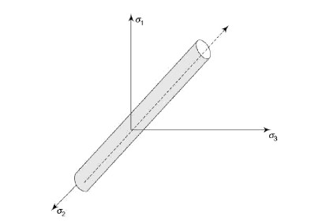

Let effective stress  *eff* corresponding to stress tensor  as

⬧  3 *s s* 

3 *s* : *s*

(4)

*eff*

2 *ij ij* 2

Where *sij* is the components of deviatoric stress tensor S.von Mises criteria can be written as

⬧ *eff*   *y*  0 where  *y* is the yield stress of the material in uniaxial tension or compression.

**Tresca yield criteria**

According to the tresca yield criteria,yielding of material begin to occur when maximum shearing stress at a point reaches a critical value.

If 1, 2, 3 are the principal stresses arranged in descending order, we can write Tresca criterion

as

1

− 

⬧

2 1 2

 *KT*

(1)

where KT is the material dependent parameter determined experimentally.If

stress ,the maximum shear is  2 .Tresca condition can be written as

2

⬧ *y* be the yield

1   3

  *y* or in terms of

❒ *and*

❒ sin       2*k*





3







( 2)

The maximum shear stress at appoint does not change when the state of stress at the point is changed hydrostatically. Tresca yield criteria represents a hexagonal cylinder in principal stress space.

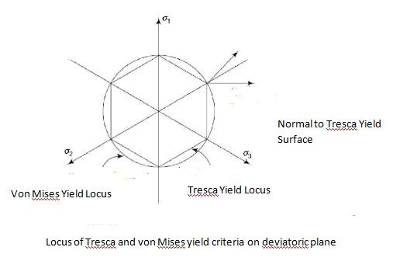

**DIFFERENCE BETWEEN HOT AND COLD WORKING**

Cold working may be defined as plastic deformation of metals and alloys at a temperature below the recrystallization temperature for that metal or alloy. In cold working process the strain hardening which occurs as a result of mechanical working, does not get relieved. In fact as the metal or alloys gets progressively strain hardened, more and more force is required to cause further plastic deformation. After sometime, if the effect of strain hardening is not removed, the forces applied to cause plastic deformation may cause cracking and failure of material.

Hot working may be explained as plastic deformation of metals and alloys at such a temperature above recrystallization temperature at which recovery and recrystallization take place simultaneously with the strain hardening.

Recrystallization temperature is not a fixed temperature but is actually a temperature range. Its value depends upon several factors. Some of the important factors are:

 **Nature of metal or alloy:** It is usually lower for pure metals and higher for alloys. For pure metals, recrystallization temperature is roughly one third of its melting point and for alloys about half of the melting temperature.

 **Amount of cold work already done:** The recrystallization temperature is lowered as the amount of strain-hardening done on the work piece increases.

 **Strain-rate:** Higher the rate of strain hardening, lower is the recrystallization temperature. For mild steel, recrystallization temperature range may be taken as 550–

650°C. Recrystallization temperature of low melting point metals like lead, zinc and tin, may be taken as room temperature. The effects of strain hardening can be removed by annealing above the recrystallization temperature.

**ADVANTAGES AND DISADVANTAGES OF COLD AND HOT WORKING PROCESSES**

 As cold working is practically done at room temperature, no oxidation or tarnishing of surface takes place. No scale formation is there, hence there is no material loss where as in hot working, there is scale formation due to oxidation besides, hot working of steel also results in partial decarburization of the work piece surface as carbon gets oxidized as CO2.

 Cold working results in better dimensional accuracy and a bright surface. Cold rolled steel bars are therefore called bright bars, while those produced by hot rolling process are called black bars (they appear greyish black due to oxidation of surface.

 In cold working heavy work hardening occurs which improves the strength and hardness of bars, and high forces are required for deformation increasing energy consumption. In hot working this is not so.

 Due to limited ductility at room temperature, production of complex shapes is not possible by cold working processes.

 Severe internal stresses are induced in the metal during cold working. If these stresses are not relieved, the component manufactured may fail prematurely in service. In hot working, there are no residual internal stresses and the mechanically worked structure is better than that produced by cold working.

 The strength of materials reduces at high temperature. Its malleability and ductility improve at high temperatures. Hence low capacity equipment is required for hot working processes. The forces on the working tools also reduce in case of hot working processes.

 Sometimes, blow holes and internal porosities are removed by welding action at high temperatures during hot working.

 Non-metallic inclusions within the work piece are broken up. Metallic and non-metallic segregations are also reduced or eliminated in hot working as diffusion is promoted at high temperatures making the composition across the entire cross-section more uniform.

**Effect of strain rate on forming process**

Higher the rate of strain hardening, lower is the recrystallization temperature. For mild steel, recrystallization temperature range may be taken as 550–650°C. Recrystallization temperature of low melting point metals like lead, zinc and tin, may be taken as room temperature. The effects of strain hardening can be removed by annealing above the recrystallization temperature.

**Forging**

Forging is a basic process in which the work piece is shaped by compressive forces applied through various dies and tooling. It is one of the oldest and most important metalworking operations used to make jewelry, coins, and various implements by hammering metal with tools made of stone. Forged parts now include large rotors for turbines; gears; bolts and rivets; cutlery); hand tools; numerous structural components for machinery, aircraft and railroads and a variety of other transportation equipment.

Simple forging operations can be performed with a heavy hammer and an anvil, as has been done traditionally by blacksmiths. However, most forgings require a set of dies and such equipment as a press or a powered forging hammer.

Forging may be carried out at room temperature (cold forging) or at elevated temperatures (warm or hot forging) depending on the homologous temperature. Cold forging requires higher forces (because of the higher strength of the work piece material), and the work piece material must possess sufficient ductility at room temperature to undergo the necessary deformation without cracking. Cold-forged parts have a good surface finish and dimensional accuracy. Hot forging requires lower forces, but the dimensional accuracy and surface finish of the parts are not as good as in cold forging. Forgings generally are subjected to additional finishing operations, such as heat treating to modify properties and machining to obtain accurate final dimensions and a

good surface finish. These finishing operations can be minimized by precision forging, which is an important example of net-shape or near-net-shape

forming processes. As we shall seen components that can be forged successfully also may be manufactured economically by other methods, such as casting, powder metallurgy, or machining

.Each of these will produce a part having different characteristics, particularly with regard to strength, toughness, dimensional accuracy, surface finish, and the possibility of internal or external defects.

In forging the material is deformed applying either impact load or gradual load. Based on the type of loading, forging is classified as hammer forging or press forging. Hammer forging involves impact load, while press forging involves gradual loads.

Based on the nature of material flow and constraint on flow by the die/punch, forging is classified as open die forging, impression die forging and flashless forging.

**OPEN DIE FORGING:** In this, the work piece is compressed between two platens. There is no constraint to material flow in lateral direction. Open die forging is a process by which products are made through a series of incremental deformation using dies of relatively simple shape. The top die is attached to ram and bottom die is attached to the hammer anvil or press bed. Metal work piece is heated above recrystalline temp from 1900 to 24000c.Most open die forging are produced on flat dies. Convex surface dies and concave surface dies are also used in pairs or with flat dies.

Open die forging is classified into three main types, namely, cogging, fullering and edging. **Cogging: Cogging** (also called as drawing out) consists of a sequence in which the thickness of an ingot is reduced to billet or blooms by narrow dies. **Fullering and Edging** operations are done to reduce the cross section using convex shaped or concave shaped dies. Material gets distributed and hence gets elongated and reduction in thickness happens. **Upsetting** is an open die forging in which the billet is subjected to lateral flow by the flat die and punch. Due to friction the material flow across the thickness is non-uniform. Material adjacent to the die gets restrained from flowing, whereas, the material at center flows freely. This causes a phenomenon called barreling in upset forging.

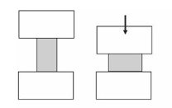

**Open die forging**

**IMPRESSION DIE FORGING**

Here half the impression of the finished forging is sunk or made in the top die and other half of the impression is sunk in the bottom die. In impression die forging, the work piece is pressed between the dies. As the metal spreads to fill up the cavities sunk in the dies, the requisite shape is formed between the closing dies. Some material which is forced out of the dies is called “flash”. The flash provides some cushioning for the dies, as the top strikes the anvil. The flash around the work piece is cut and discarded as scrap. For a good forging, the impression in the dies has to be completely filled by the material. This may require several blows of the hammer, a single blow may not be sufficient.

**CLOSED DIE FORGING**

Closed die forging is very similar to impression die forging, but in true closed die forging, the amount of material initially taken is very carefully controlled, so that no flash is formed. Otherwise, the process is similar to impression die forging. It is a technique which is suitable for mass production.

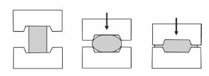

**Closed die forging**

**DROP FORGING**

Drop forging utilizes a closed impression die to obtain the desired shape of the component. The shaping is done by the repeated hammering given to the material in the die cavity. The equipment used for delivering the blows are called drop hammers.

Drop forging die consists of two halves. The lower half of the die is fixed to the anvil of the machine while the upper half is fixed to the ram. The heated stock is kept in the lower die. While the ram delivers four to five blows on the metal, in quick succession so that the metal spread and completely fills the die cavity. When the two die halves closed the complete cavity is formed.

The **die impressions** are machined in the die cavity, because of more complex shapes can be obtained in drop forging, compared to smith forging. However too complex shape with internal cavities, deep pockets, cannot be obtained in drop forging. Due to limitation of withdrawal of finished forging from die. The final shape desired in drop forging cannot be obtained directly from the stock in the single pass. Depending upon the shape of the component, the desired grain flow direction and the material should be manipulated in a number of passes. Various passes are used are

**Fullering impression:** Since drop forging involves only a reduction in cross section with no upsetting, the very first step to reduce the stock is fullering.The impression machined in the die to achieve this is called fullering impression.

**Edging impression**: Also called as preform. This stage is used to gather the exact amount of material required at each cross-section of the finished component. This is the most important stage in drop forging.

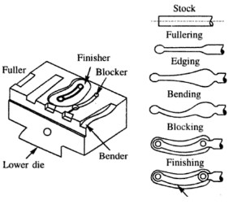

**Bending impression:**

This is required for those parts which have a bend shape. The bend shape can also be obtained without the bending impressions. Then the grain flow direction will not follow the bend shape and thus the point of bend may become weak. To improve the grain flow, therefore a bending impression is incorporated after edging impression.

**Blocking impression:**

It is also called as semi finshing impression. Blocking is a step before finishing. In forging, it is difficult for the material to flow to deep pockets, sharp corners etc. Hence before the actual shape is obtained, the material is allowed to have one or more blocking impressions where it requires the shape very near to final one. The blocking impression is characterized by large corner radii and fillet but no flash.

**Finishing impression:**

This is the final impression where the actual shape required obtained. In order to ensure that the metal completely fills the die cavity, a little extra metal is added to the stock. The extra metal will form the flash and surround the forging in the parting plane.

**Trimming:**

In this stage the extra flash present around the forging is trimmed to get the forging in the usable form.

**PRESS FORGING**

Press forging dies are similar to drop forging dies as also the process. In press forging the metal is shaped not by means of a series of blows as in drop forging, but by means of a single continuous squeezing action. This squizing is obtained by means of hydraulic presses. Because of continuous action of the hydraulic presses, the material gets uniformly deformed throughout the entire depth. More hammer force is likely to be transmitted to the machine frame in drop forging where in press forging it is absorbed fully by stock. The impression obtained in press forging is clean compared to that of jarred impression which is like in drop forged component. The draft angle in press forging is less than in drop forging. But the press capacity required for deforming is higher and as a result the smaller sized component only are press forged in closed impression dies. The presses have capacities ranging from 5MN to 50 MN for normal application For special heavy duty application, higher capacity press of order 150 MN are required.

To provide the necessary alignment the two halves, die post are attached to the bottom die so that the top die would slide only on the post and thus register the correct alignment. This ensures better tolerance for press forged components.

**FORGING DEFECTS**

The common forging defects can be traced to defects in raw material, improper heating of material, Faulty design of dies and improper forging practice. Most common defects present in forgings are:

 Laps and Cracks at corners or surfaces lap is caused due to following over of a layer of material over another surface. These defects are caused by improper forging and faulty die design.

 Incomplete forging—either due to less material or inadequate or improper flow of material.

 Mismatched forging due to improperly aligned die halves.

 Scale pits—due to squeezing of scales into the metal surface during hammering action.

 Burnt or overheated metal—due to improper heating.

 Internal cracks in the forging which are caused by use of heavy hammer blows and improperly heated and soaked material.

 Fibre flow lines disruption due to very rapid plastic flow of metal.

**UPSET FORGING DIE DESIGN**

In upset forging there is no reduction in cross section and stock length chosen is smallest area of cross section. Here very negligible flash is provided. Depending upon the shape of upsetting ,the number of passes or blows in the dies are to be designed. The amount of upsetting done in a single stage is limited. Three rules are to be followed for safe amount of upsetting.

1. Maximum length of unsupported stock can be gathered or upset in a single pass. It is not more than three times the stock diameter. Beyond the length material is likely to buckle. Under axial upsetting load than be upset as shown below in figure

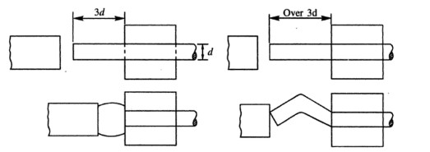

(a) Stock upset (b) Stock buckle

2. If the stock longer than three times the diameter is to be upset in a single blow, then the following conditions should be complied. The die cavity should not be wider than 1.5 times the stock diameter and the free length of the stock outside the die should be less than half the stock diameter. If these conditions are not complied, the stock would bend.

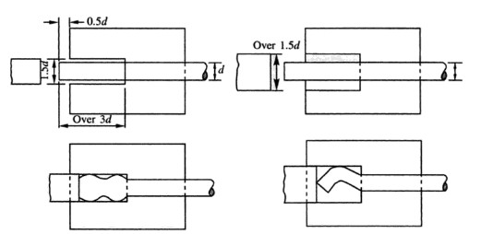

3. For upsetting the stock which is longer than three times the diameter and the free length of stock outside the die is up to 2.5 times the diameter, the following conditions should be satisfied. The material is to be confined into a conical cavity made in punch with the mouth diameter not exceeding 1.5 times the stock diameter and bottom size being 1.25 times the stock diameter. Also the necessary that the heading tool recess be not less than two thirds the length of the work ing stock or not less than the working stock minus 2.5 times the stock diameter

**FORGING DESIGN**

It is necessary to design the shape of forging to be obtained from the die.

**Parting Plane**

A Parting plane is the plane in which the two die halves of forging meet. It could be a simple plane ar irregularly bent, depending upon the shape of forging. The choice of proper parting plane greatly influences the cost of the die as well as the grain flow in the forging.

In any forging, the parting plane should be largest cross sectional area of forging, since it is easier to spread the metal than to force it into deep pockets. A flat parting plane is more economical. Also the parting plane chosen in such a way that the amount of material is located in each of the two die haves so that no deep die cavities are required It may be required to put more metal into the top die half since metal would flow more readily in the top half than in the bottom half.

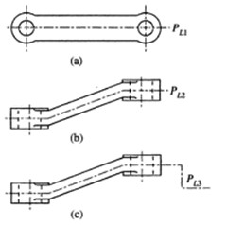

**Fillet and corner radii**

Forging involves the flow of metal in an orderly manner.Therefore it is necessary to provide a streamlined path for the flow of metal so that defects free forging are produced.When two or more surface met a corner is produced which restrict the flow of metal.Therfore these corners are to be rounded off to improve the flow of metal.Fillets are for rounding the internal angles wher corner is that of the external angles.

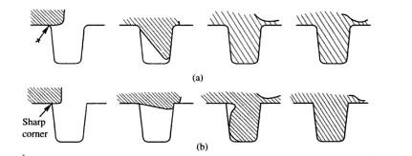

Effect of edge radius on floe metal

**Allowance**

**Shrinkage allowance**

The forging are generally made at room temperature of 1150 to 13000c.At this temperature, the material gets expanded and when it is cooled to the atmospheric temperature, it dimension would be reduced. It is very difficult to control the temperature at which forging process would be complete, therefore to precisely control the dimensions.

The forgings are generally made at a temperature of 1150 to 13000C. At this temperature, the material gets expanded and when it is cooled to the atmospheric temperature, its dimension would be reduced. It is difficult to control the temperature at which forging process would be complete. Therefore precisely control the dimensions.

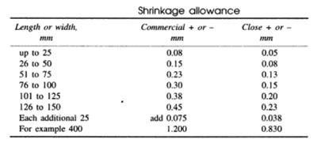

**Die wear allowance**

The die wear allowance is added to account for the gradual wear of the die which takes place with the use of die.

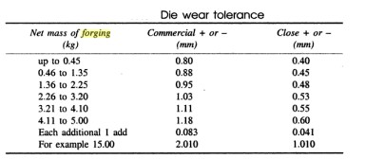

**Finish allowance**

Matching allowance is to be provided on various forged surfaces which need to be further machined. The amount of allowance to be provided should account for the accuracy, the depth of the decarburized layer. Also the scale pits that are likely to form on the component should also be removed by machining.

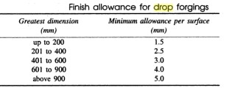

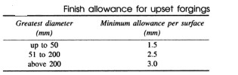

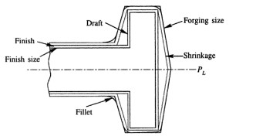

Allowances shown on forged component

**Stock**

Drop forging do not get upset and therefore the stock size to be chosen depends upon the largest cross sectional area of the component. To get the stock size the flash allowance is to be provided over and above the stock volume. The stock to be used either round, rectangular or any other cross section depending upon the nature of component. Having decided on the cross section of the stock, and from the total volume of the component and the flash, it is possible to find the length of the stock. The stock of the die is to be moved from one impression to other and hence a tong hold is provided in addition to the length of the stock.

**Rolling**

**INTRODUCTION**

In this process, metals and alloys are plastically deformed into semifinished or finished products by being pressed between two rolls which are rotating. The metal is initially pushed into the space between two rolls, thereafter once the roll takes a ‘‘bite’’ into the edge of the material, the material gets pulled in by the friction between the surfaces of the rolls and the material. The material is subjected to high compressive force as it is squeezed (and pulled along) by the rolls. This is a process to deal with material in bulk in which the cross-section of material is reduced and its length increased. The final cross-section is determined by the impression cut in the roll surface through which the material passes and into which it is compressed. The essentials of the rolling process can be understood from the Fig

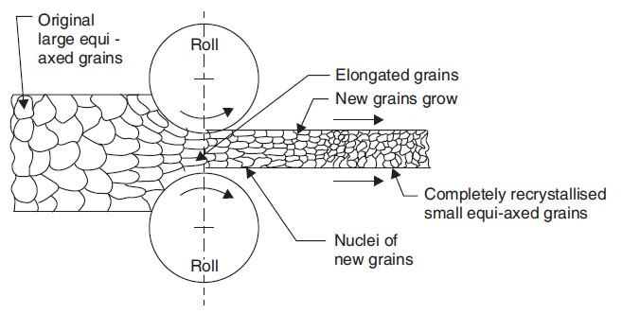

Rolling is done both hot and cold. In a rolling mill attached to a steel plant, the starting point is a cast ingot of steel which is broken down progressively into blooms, billets and slabs. The slabs are further hot rolled into plate, sheet, rod, bar, rails and other structural shapes like angles, channels etc. Conversion of steel into such commercially important sections is usually done in another rolling mill called merchant mill.

Rolling is a very convenient and economical way of producing commercially important sections. In the case of steel, about three-fourth’s of all steel produced in the country is ultimately sold as a rolled product and remaining is used as forgings, extruded products and in cast form. This shows the importance of rolling process.

**NOMENCLATURE OF ROLLED PRODUCTS**

The following nomenclature is in common usage:

(*i*) **Blooms:** It is the first product obtained from the breakdown of Ingots. A bloom has a crosssection ranging in size from 150 mm square to 250 mm square or sometimes 250 × 300 mm rectangle.

(*ii*) **Billet:** A billet is the next product rolled from a bloom. Billets vary from 50 mm square to

125 mm square.

(*iii*) **Slab:** Slab is of rectangular cross-section with thickness ranging from 50 to 150 mm and is available in lengths up to 112 metres.

(*iv*) **Plate:** A plate is generally 5 mm or thicker and is 1.0 or 1.25 metres in width and 2.5 metres in length.

(*v*) **Sheet:** A sheet is up to 4 mm thick and is available in same width and length as a plate.

(*vi*) **Flat:** Flats are available in various thickness and widths and are long strips of material of specified cross-section.

(*vii*) **Foil:** It is a very thin sheet.

(*viii*) **Bar:** Bars are usually of circular cross-section and of several metres length. They are common stock (raw material) for capstan and turret lathes.

(*ix*) **Wire:** A wire is a length (usually in coil form) of a small round section; the diameter of which specifies the size of the wire.

**MECHANISM OF ROLLING**

Each of the two rolls contact the metal surface along the arc *AB*, which is called arc of contact. Arc *AB* divided by the radius of rolls will gives angle of contact (α). The rollers pull the material forwards only due to the friction existing between roll surface and the metal. At the moment of the bite, the reaction at the contact point *A* will be *R* acting along radial line *O*1*A* and frictional force will be acting along tangent at *A* at right angles to *O*1*A.* In the limiting case,

*R* sin α = μ*R* cos α

∴ μ = tan α or α = tan–1 μ

If α is greater than tan–1 μ, the material would not enter the rolls unaided.

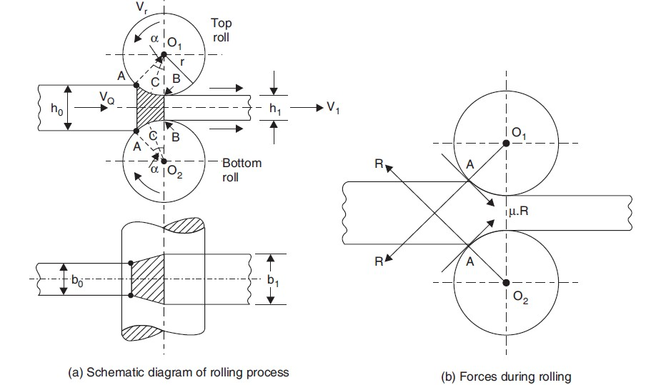

cos 

*r*  1

2

 *h*0  *h*1 

*r*

, where *h*0 is the thickness of material, *h*1 the gap between the two rollers

at the narrowest point and *r* is the radius of rollers. For a given diameter of rollers and gap between them the value of *h*0 is limited by the value of μ which in turn depends upon the material of rolls and job being rolled, the roughness of their surfaces and the rolling temperature and speed. In case of hot rolling when maximum reduction is cross-section per pass is aimed at, it may be necessary to artificially increase the value of μ by ‘‘ragging’’ the surface of rolls. Ragging means making the surface of rolls rough by making fine grooves on the roll-surface. However, in cold rolling which is a finishing operation and cross-section reduction is limited, ragging of rolls is neither required nor desirable. In fact, in that case, some lubrication is resorted to in addition to giving a fine finish to the rolls. Another reason for making do with a lower coefficient of friction in cold rolling is that in this process, very high pressures are used and even with a low value of μ, adequate frictional force becomes available.

The usual values of biting angles employed in industry are:

2–10° ... for cold rolling of sheets and strips;

15–20° ... for hot rolling of sheets and strips;

24–30° ... for hot rolling of heavy billets and blooms.

In the rolling process, although the material is being squeezed between two rolls, the width (*b*0) of the material does not increase or increases only very slightly. Since volume of material entering the rolls is equal to the volume of material leaving the rolls, and the thickness of material reduces from *h*0 to *h*1, the velocity of material leaving the rolls must be higher than the velocity of material entering the rolls. The rolls are moving at a uniform r.p.m. and their surface speed remains constant. The rolls are trying to carry the material into the rolls with the help of friction alone, there is no positive grip between rolls and the material. On one side, therefore, *i.e.,* point *A* where contact between the rolls and work material starts, the rolls are moving at faster surface speed than the work material. As the material gets squeezed and passes through the rollers, its speed gradually increases and at a certain section *CC* called neutral or no slip section, the velocity of metal equals the velocity of rolls. As material is squeezed further, its speeds exceed the speed of the rolls. The angle subtended at the centre of the roll at the neutral section is called angle of no slip or critical angle (angle *BO*1*C*).

The deformation zone to the left of the neutral section is called lagging zone and the deformation zone to the right of the neutral section is termed leading zone. If *Vr* is the velocity of roll surface, *V*0 the velocity of material at the entrance to the deformation zone and *V*1 at the exit of the rolls, we have

Forward slip= *V*1  *Vr* 100 percent

*Vr*

Backward slip= *Vr*  *V*0 100 percent

*Vr*

The value of forward slip normally is 3–10% and increases with increase in roll diameter and coefficient of friction and also with reduction in thickness of material being rolled. Some other useful terms associated with rolling are explained below:

Absolute draught: *h*  *hi*  *h*0 mm

Relative draught: *h* 100 percent

*h*1

Absolute elongation, Δ*l* = Final length – Original length of work material

Coefficient of elongation = Final length/Original length

Absolute spread = Final width of work material – Original width of material

**TYPES OF ROLLING MILLS**

Different types of rolling mills are described below in brief:

**Two high mills:** It comprises of two heavy rolls placed one over the other. The rolls are supported in bearings housed in sturdy upright frames (called stands) which are grouted to the rolling mill floor. The vertical gap between the rolls is adjustable. The rolls rotate in opposite directions and are driven by powerful electrical motors. Usually the direction of rotation of rolls cannot be altered, thus the work has to be fed into rolls from one direction only. If rolling entails more than one ‘pass’ in the same set of rolls, the material will have to be brought back to the same side after the first pass is over. Since transporting material (which is in red hot condition) from one side to another is difficult and time consuming (material may cool in the meantime), a

‘‘two high reversing mill’’ has been developed in which the direction of rotation of rolls can be changed. This facilitates rolling of material by passing it through back and forth passes. A two high rolling mill arrangement is shown in Fig.

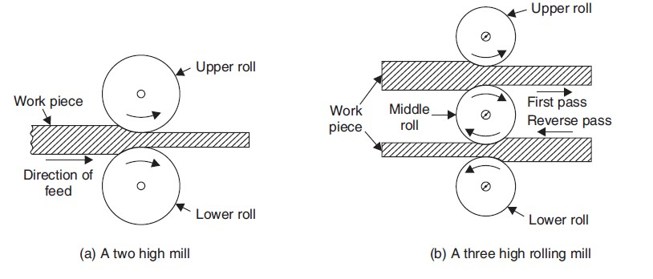

**Three high mills:** A three high rolling mill arrangement is shown in Fig. It consists of three rolls positioned directly over one another as shown. The direction of rotation of the first and second rolls are opposite as in the case of two high mill. The direction of rotation of second and third rolls is again opposite to each other. All three rolls always rotate in their bearings in the same

direction. The advantage of this mill is that the work material can be fed in one direction between the first and second roll and the return pass can be provided in between the second and third rolls. This obviates the transport of material from one side of rolls to the other after one pass is over.

**Four high mills:** As shown in Fig, this mill consists of four horizontal rolls, two of smaller diameter and two much larger ones. The larger rolls are called backup rolls. The smaller rolls are the working rolls, but if the backup rolls were not there, due to deflection of rolls between stands, the rolled material would be thicker in the centre and thinner at either end. Backup rolls keep the working rolls pressed and restrict the deflection, when the material is being rolled. The usual products of these mills are hot and cold rolled plates and sheets.

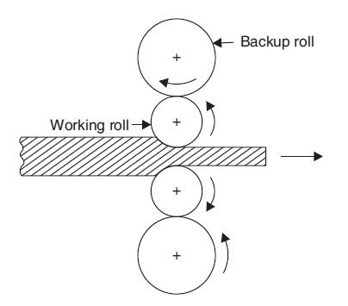

**Cluster mills:** It consists of two working rolls of small diameter and four or more backing rolls. The large number of backup rolls provided becomes necessary as the backup rolls cannot exceed the diameter of working rolls by more than 2–3 times. To accommodate processes requiring high rolling loads (*e.g.,* cold rolling of high strength steels sheets), the size of working rolls becomes small. So does the size of backup rolls and a stage may be reached that backup rolls themselvesmay offer deflection. So the backup rolls need support or backing up by further rolls.

**Geometric Considerations**

Because of the forces acting on them, rolls undergo changes in shape during rolling. just as a straight beam deflects under a transverse load, roll forces tend to bend the rolls elastically during rolling As expected, the higher the elastic modulus of the roll material, the smaller the roll deflection. As a result of roll bending, the rolled strip tends to be thicker at its center than at its edges (crown). The usual method of avoiding this problem is to grind the rolls in such way that their diameter at the center is slightly larger than at their edges (camber). Thus, when the roll bends, the strip being rolled now has a constant thickness along its width For rolling sheet metals, the radius of the maximum camber point is generally 0.25 mm greater than that at the edges of the roll. However, as expected, a particular camber is correct only for a certain load and strip width. To reduce the effects of deflection, the rolls also can be subjected to external bending by applying moments at their bearings

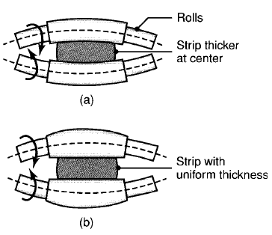

(a) Bending of straight cylindrical rolls caused by roll forces. (b) Bending of rolls ground with camber, producing a strip with uniform thickness through the strip width.

**ROLLS AND ROLL PASS DESIGN**

Two types of rolls—Plain and Grooved are shown in Fig. 3.5. Rolls used for rolling consists of three parts *viz*., body, neck and wabbler. The necks rest in the bearings provided in the stands

and the starshaped wabblers are connected to the driving shaft through a hollow cylinder. Wabbler acts like a safety device and saves the main body of the roll from damage if too heavy a load causes severe stresses. The actual rolling operation is performed by the body of the roll. The rolls are generally made from a special variety of cast iron, cast steel or forged steel. Plain rolls have a highly finished hard surface and are used for rolling flats, plates and sheets. Grooved rolls

have grooves of various shapes cut on their periphery. One-half of the required shape of rolled product is sometimes cut in the lower roll and one-half in the upper roll, so that when the rolls are assembled into its stands, the required shape in full will be produced on the work material, once it passes (*i.e.,* rolled) through the groove in question. However it should be understood that the desired shape of the rolled section is not achieved in a single pass. The work material has to be rolled again and again through several passes and each pass brings the cross-section of the material closer to the final shape required. These passes are carefully designed to avoid any rolling defect from creeping in. Rolling is a painstaking process as would be noticed from the scheme of passes shown in Figure for conversion of a steel billet into a round bar.

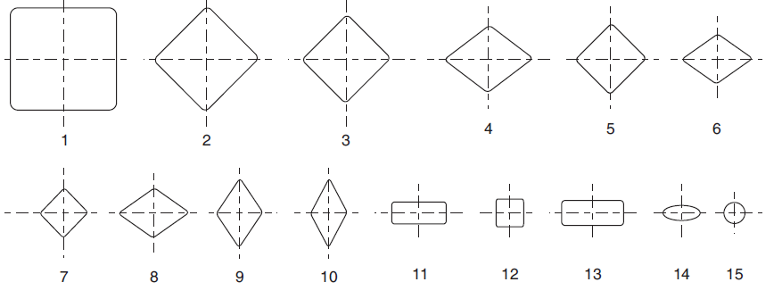

Various stages of rolling and the number of passes for converting a steel billet into round bar

Various passes fall into the following groups: (*i*) Breakdown or roughing passes,

(*ii*) Leader passes, and

(*iii*) Finishing passes.

Breakdown passes are meant to reduce the cross-sectional area. The leader passes gradually bring the cross-section of the material near the final shape. The final shape and size is achieved in finishing passes. Allowance for shrinkage on cooling is given while cutting the finishing pass grooves.

**Defects inRolling**

**Defects** may be present on the surfaces of rolled plates and sheets, or there may be internal structural defects. Defects are undesirable not only because they compromise surface appearance, but also because they may adversely affect strength, formability, and other manufacturing characteristics. Several surface defects (such as scale, rust, scratches, gouges, pits, and cracks) have been identified in sheet metals. These defects may be caused by inclusions and impurities in the original cast material or by various other conditions related to material preparation and to the rolling operation. Wavy edges on sheets are the result of roll bending. The strip is thinner along its edges than at its center); thus, the edges elongate more than the center. Consequently, the edges buckle because they are constrained by the central region from expanding freely in the longitudinal (rolling) direction. The cracks are usually the result of poor material ductility at the rolling temperature. Because the quality of the edges of the sheet may affect sheet-metal-forming operations, edge defects in rolled sheets often are removed by shearing and slitting operations. Alligatoring is the phenomenon and typically is caused by non uniform bulk deformation of the billet during rolling or by the presence of defects in the original cast material.

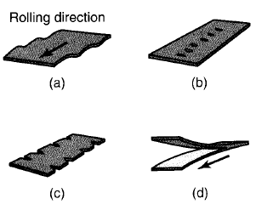

(a) wavy edges; (b) zipper cracks in the center of the strip; (c) edge cracks; and (d) alligatoring

**EXTRUSION**

Extrusion is a process in which the metal is subjected to plastic flow by enclosing the metal in a closed chamber in which the only opening provided is through a die. The material is usually treated so that it can undergo plastic deformation at a sufficiently rapid rate and may be squeezed out of the hole in the die. In the process the metal assumes the opening provided in the die and comes out as a long strip with the same cross-section as the die-opening. Incidentally, the metal strip produced will have a longitudinal grain flow. The process of extrusion is most commonly used for the manufacture of solid and hollow sections of nonferrous metals and alloys *e.g*., aluminium, aluminium-magnesium alloys, magnesium and its alloys, copper, brass and bronze etc. However, some steel products are also made by extrusion. The stock or the material to be extruded is in the shape of cast ingots or billets. Extrusion may be done hot or cold. The cross- sections of extruded products vary widely.

Some advantages of extrusion process are described below:

 The complexity and range of parts which can be produced by extrusion process is very large.

 Dies are relative simple and easy to make.

 The extrusion process is complete in one pass only. This is not so in case of rolling, amount of reduction in extrusion is very large indeed. Extrusion process can be easily automated.

 Large diameter, hollow products, thin walled tubes etc. are easily produced by extrusion process.

 Good surface finish and excellent dimensional and geometrical accuracy is the hall mark of extruded products. This cannot be matched by rolling.

Pressure required for extrusion depends upon the strength of material and upon the extrusion temperature. It will reduce if the material is hot. It will also depend upon the reduction in cross- section required and the speed of extrusion. There is a limit to the extrusion speed. If extrusion is done at a high speed, the metal may crack. The reduction of cross-sectional area required is also called “extrusion ratio”. There is a limit to this also. For steel extruded hot, this ratio should not exceed 40 : 1, but for aluminium extruded hot it can be as high as 400 : 1.

**EXTRUSION PROCESSES**

Extrusion processes can be classified as followed: (A) **Hot Extrusion**

(*i*) Forward or Direct extrusion.

(*ii*) Backward or Indirect extrusion. (B) **Cold Extrusion**

(*i*) Hooker extrusion.

(*ii*) Hydrostatic extrusion. (*iii*) Impact extrusion.

(*iv*) Cold extrusion forging.

**A. Hot Extrusion Processes**

(*i*) **Forward or direct extrusion process:** In this process, the material to be extruded is in the form of

a block. It is heated to requisite temperature and then it is transferred inside a chamber as shown in Fig. In the front portion of the chamber, a die with an opening in the shape of the cross-section of the extruded product, is fitted. The block of material is pressed from behind by means of a ram and a follower pad. Since the chamber is closed on all sides, the heated material is forced to squeeze through the die-opening in the form of a long strip of the required cross-section.

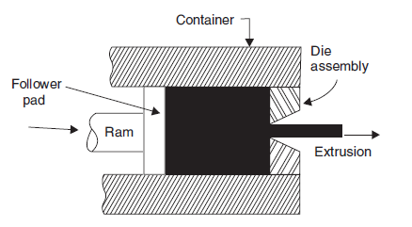

**Forward or direct extrusion**

The process looks simple but the friction between the material and the chamber walls must be overcome by suitable lubrication. When extruding steel products, the high temperautre to which

the steel has to be heated makes it difficult to find a suitable lubricant. The problem is solved by using molten glass as a lubricant. When lower temperatures are used, a mixture of oil and graphite is used as a lubricant. At the end of the extrusion process, a small piece of metal is left behind in the chamber which cannot be extruded. This piece is called butt—end scrap and is thrown away. To manufacture a tubular rod, a mandrel of diameter equal to that of tube—bore is attached to the ram. This mandrel passes centrally through the die when the material is extruded. The outside diameter of the tube produced will be determined by the hole in the die and the bore of tube will be equal to mandrel diameter. The extrusion process will then called “tubular extrusion”.

**Backward or indirect extrusion:** This process is depicted in Figure. As shown, the block of heated metal is inserted into the container/chamber. It is confined on all sides by the container walls except in front; where a ram with the die presses upon the material. As the ram presses backwards, the material has to flow forwards through the opening in the die. The ram is made hollow so that the bar of extruded metal may pass through it unhindered.

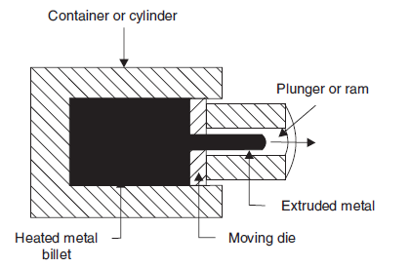

**Backward or Indirect extrusion**

This process is called backward extrusion process as the flow of material is in a direction opposite

to the movement of the ram. In the forward extrusion process the flow of material and ram movement Were both in the same direction. The following table compares the forwards (direct) and backwards (Indirect extrusion process).

**Comparison between Forward and Backward extrusion**

|  |  |
| --- | --- |
| **Forward or Direct extrusion** | **Backward or Indirect extrusion** |
| 1.Simple, but the material must slide along the  chamber wall.  2. High friction forces must be overcome.  3. High extrusion forces required but mechanically  simple and uncomplicated.  4. High scrap or material waste—18–20% on an  average. | In this case, material does not move but die  moves.  2. Low friction forces are generated as the mass of material does not move.  3. 25–30% less extruding force required as compared to direct extrusion. But hollow ram required limited application.  4. Low scrap or material waste only 5–6% of billet weight. |

**Cold Extrusion Processes**

**Hooker extrusion process:** This process is also known as extrusion down method. It is used for producing small thin walled seamless tubes of aluminium and copper. This is done in two stages. In the first stage the blank is converted into a cup shaped piece. In the second stage, the walls of the cup one thinned and it is elongated. The process can be understood by referring to Figure. This process is a direct extrusion process.

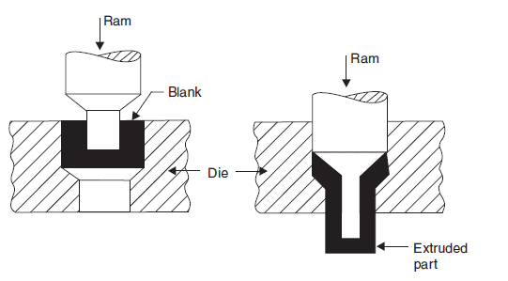

Hooker extrusion

**Hydrostatic extrusion:** This is a direct extrusion process. But the pressure is applied to the metal blank on all sides through a fluid medium. The fluids commonly used are glycerine, ethyl glycol, mineral oils, castor oil mixed with alcohol etc. Very high pressures are used – 1000 to

3000 MPa. Relatively brittle materials can also be successfully extruded by this method.

**Impact extrusion:** In this process, which is shown in Figure the punch descends with high velocity and strikes in the centre of the blank which is placed in a die. The material deforms and fills up the annular space between the die and the punch flowing upwards. Before the use of laminated plastic for manufacturing tooth paste, shaving cream tubes etc., these collapsible tubes containing paste were and are still made by this process. Other examples of products made by impact extrusion are light fixtures, automotive parts, and small pressure vessels. Most nonferrous metals can be impact extruded in vertical presses and at production rates as high as two parts per second. This process is actually a backward extrusion process.

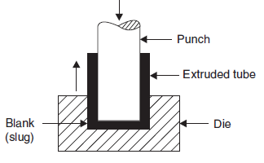

Impact extrusion

**Cold extrusion forging:** This process is depicted in Figure. This is generally similar to the impact extrusion process; but there are two differences: In this process the punch descends slowly. The height of extruded product is short and the side walls are much thicker than the thin walled products produced by the impact extrusion process. In essence, this process is one of backward extrusion.

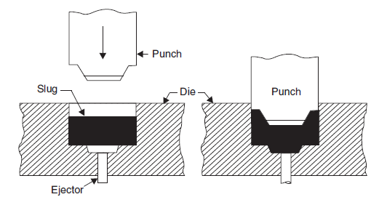

Cold extrusion process

**Comparision between Hot extrusion and Cold extrusion**

|  |  |
| --- | --- |
| ***Cold extrusion*** | ***Hot extrusion*** |
| Better surface finish and lack of oxide layers.  2. Good control of dimensional tolerance—no  Machining or very little machining required.  3. High production rates at low cost. Fit for individual  Component production.  4. Improved mechanical properties due to strain hardening.  5. Tooling subjected to high stresses.  6. Lubrication is crucial. | 1.Surface is coated with oxide layers. Surface finish  not comparable with cold extrusion.  2. Dimensional control not comparable with cold extrusion products.  3. High production rates but process fit for bulk material, not individual components.  4.Since processing is done hot, recrystallisation takes place.  5. Tooling subjected to high stresses as well as to high temperature. Tooling stresses are however lower than for cold extrusion.  6. Lubrication is crucial. |

**EXTRUSION DEFECTS**

Sometimes the surface of extruded metal/products develops surface cracks. This is due to heat generated in the extrusion process. These cracks are specially associated with aluminium, magnesium and zinc alloy extrusions. The extruded product can develop internal cracks also. These are variously known as centre burst, centre cracking and arrowhead fracture. There are three principal extrusion defects: surface cracking, pipe, and internal cracking.

**Surface Cracking**:

If extrusion temperature, friction, or speed is too high, surface temperatures can rise significantly, which may cause surface cracking and tearing. These cracks are intergranular (i.e., along the grain boundaries. and usually are caused by hot shortness . These defects occur especially in aluminum, magnesium, and zinc alloys, although they may also occur in high- temperature alloys. This situation can be avoided by lowering the billet temperature and the extrusion speed. Surface cracking also may occur at lower temperatures, where it has been

attributed to periodic sticking of the extruded product along the die land. Because of the similarity in appearance to the surface of a bamboo stem, it is known as a bamboo defect. When the product being extruded temporarily sticks to the die land. The extrusion pressure increases rapidly. Shortly thereafter, the product moves forward again, and the pressure is released. The cycle is repeated continually, producing periodic circumferential cracks on the surface.

**Pipe:**

The type of metal-flow pattern in extrusion tends to draw surface oxides and impurities toward the center of the billet-much like a funnel. This defect is known as pipe defect, tailpipe, or fis/atailing. As much as one-third of the length of the extruded product may contain this type of defect and thus has to be cut off as scrap. Piping can be minimized by modifying the flow pattern to be more uniform, such as by controlling friction and minimizing temperature gradients. Another method is to machine the billet’s surface prior to extrusion, so that scale and surface impurities are removed. These impurities also can be removed by the chemical etching of the surface oxides prior to extrusion.

**Internal Cracking:**

The center of the extruded product can develop cracks, called center cracking, center-burst, arrowhead fracture. These cracks are attributed to a state of hydrostatic tensile stress at the centerline in the deformation zone in the die, a situation similar to the necked region in a tensile- test specimen . These cracks also have been observed in tube extrusion and in tube spinning

**WIRE DRAWING**

Wire drawing is a simple process. In this process, rods made of steel or non ferrous metals and alloys are pulled through conical dies having a hole in the centre. The included angle of the cone is kept between 8 to 24°. As the material is pulled through the cone, it undergoes plastic deformation and it gradually undergoes a reduction in its diameter. At the sametime, the length is increased proportionately. The process is illustrated in Figure

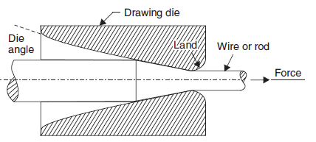.

Wire drawing process

The dies tend to wear out fast due to continuous rubbing of metal being pulled through it. Hence they are made of very hard material like alloy steel, tungsten carbide or even diamond. In one pass, the reduction in cross-sectional area achieved is about 25–30%. Hence in a wire drawing plant, the wire has to pass thorugh a number of dies of progressively reducing diameter to achieve the required reduction in diameter. However as the wire passes through dies and undergoes plastic deformation, it gets strain hardened. Its strength increases and capacity to further undergo plastic deformation decreases. Therefore during the entire run of the wire, from time to time, it has to be heated (and cooled) to remove the effect of work-hardening. This process is called “in process annealing”. The aim is to make the material soft and ductile again so that the process of drawing may be smoothly carried out. The metal rods to be drawn into wires must be absolutely clean. If necessary, they are pickled in an acid bath to dissolve the oxide layer present on the surface. Its front end is then tapered down so that it may pass through the hole in the die which is firmly held in the wire drawing machine. The wire is drawn by means of a number of power driven spools or rotating drums. During wire drawing, a great deal of heat is generated due to friction between the wire rod and the die. To reduce friction, dry soap or a synthetic lubricant is used. But despite reducing friction, the dies and drums may have to be water cooled. The preferred material for dies is tungsten carbide but for drawing fine wire, use of ruby or diamond dies is preferred. The drawing machines can be arranged in tandem so that the wire drawn by the previous die may be collected (in coil form) in sufficient quantity before being fed into the next die for further reduction in diameter. As the diameter becomes smaller, the linear speed of wire drawing is increased. The major variable in wire drawing process is (1) Reduction ratio (2) Die angle and (3) Friction. Improper control of these parameters will cause

defects in the drawn material. Defects include centre cracking (as in extrusion and for the same reasons) and formation of longitudinal scratches or folds in the material.

**TUBE DRAWING**

The ‘drawing’ process can also be used for tube drawing. Tube drawing does not mean manufacturing a tube from solid raw material. It means lengthening a tube reducing its diameter. Various arrangements used for tube drawing are shown in Figure.

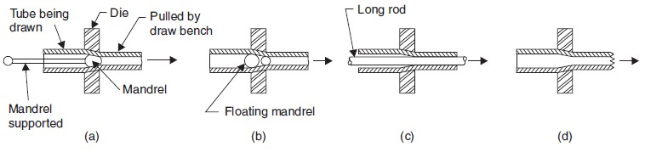

Tube drawing